**3.6.1 Exercises**

1. What geom would you use to draw a line chart? A boxplot? A histogram? An area chart?

#geom_line-line chart

#geom_boxplot-Boxplot

#geom_histogram-Histogram

#geom_area-geom_area

1. Run this code in your head and predict what the output will look like. Then, run the code in R and check your predictions.

I think the plot will have color-coded points and the smooth lines will be color-coded.

1. **ggplot**(data = mpg, mapping = **aes**(x = displ, y = hwy, color = drv)) +
2. **geom_point**() +

**geom_smooth**(se = FALSE)

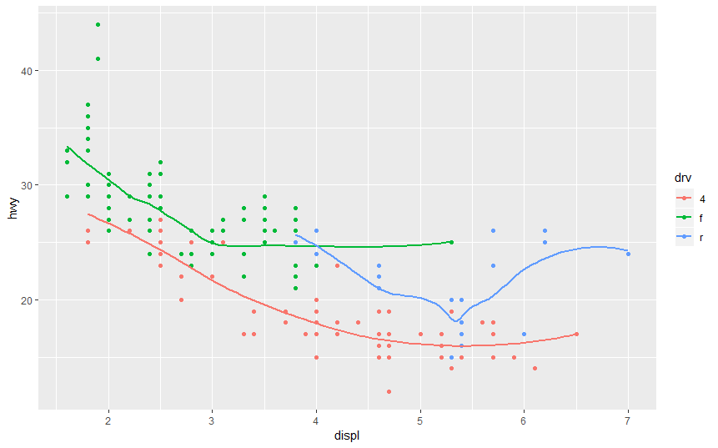

1. What does show.legend = FALSE do? What happens if you remove it?  
   Why do you think I used it earlier in the chapter?

#show.legend = FALSE removes the legend incase of use of aesthetic the requires a key (legend) eg color,shape,size etc. When you remove it the legend will appear representing various categories of a categorical variable.

#I think show.legend = FALSE  was used to avoid overcrowding the plot.

1. What does the se argument to geom_smooth() do?

# Se is used to determine standard error in geom_smooth() ,It will represent a cloud around the line if se=TRUE, and no cloud if se=FALSE

ggplot(mpg, aes(displ, hwy)) +

geom_point() +

geom_smooth(method = lm, se = TRUE)

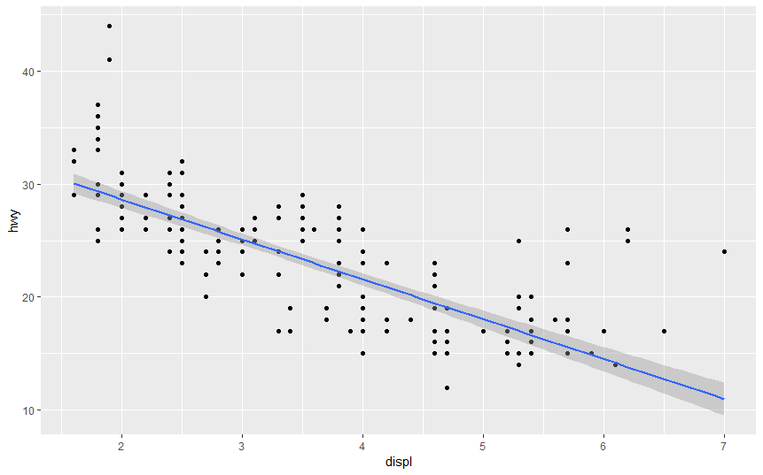

ggplot(mpg, aes(displ, hwy)) +

geom_point() +

geom_smooth(method = lm, se = FALSE)

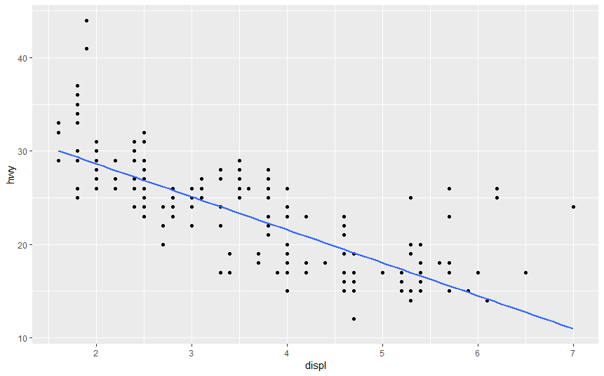

1. Will these two graphs look different? Why/why not?

**ggplot**(data = mpg, mapping = **aes**(x = displ, y = hwy)) +

**geom_point**() +

**geom_smooth**()

**ggplot**() +

**geom_point**(data = mpg, mapping = **aes**(x = displ, y = hwy)) +

**geom_smooth**(data = mpg, mapping = **aes**(x = displ, y = hwy))

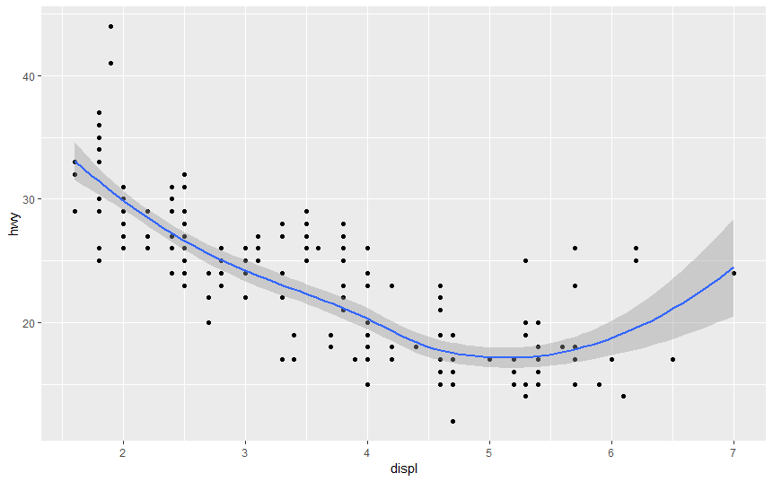 

Code 1 code 2

The plots are the same. In code the arguments of the ggplot() are declared as global arguments while in code the arguments of the ggplot() are blank but they are overwritten by the individual geom functions arguments.

1. Recreate the R code necessary to generate the following graphs.

ggplot(data=mpg,mapping =aes(x=displ,y=hwy))+

geom_point()+

geom_smooth(se=FALSE)

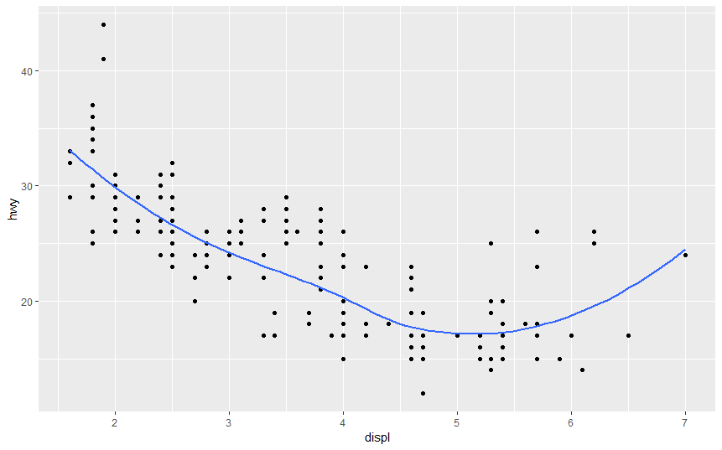

#plot2

ggplot(data=mpg)+

geom_point(mapping =aes(x=displ,y=hwy))+

geom_smooth(mapping =aes(x=displ,y=hwy,group=drv),se=FALSE)

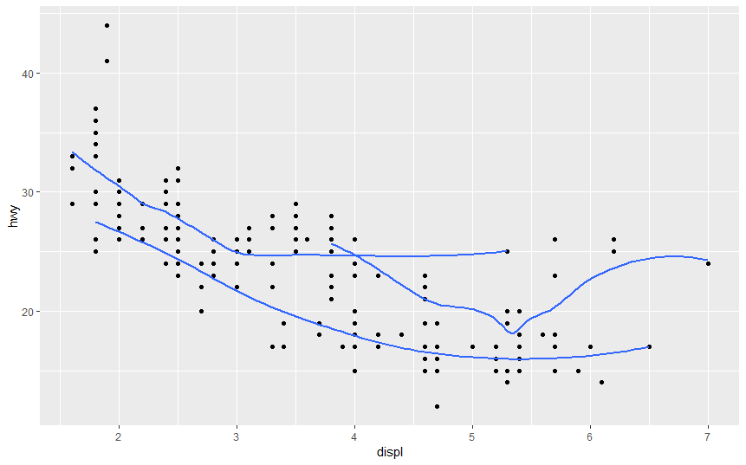

ggplot(data=mpg,mapping =aes(x=displ,y=hwy,color=drv))+

geom_point()+

geom_smooth(se=FALSE)



ggplot(data=mpg)+

geom_point(mapping =aes(x=displ,y=hwy,color=drv))+

geom_smooth(mapping =aes(x=displ,y=hwy),se=FALSE)

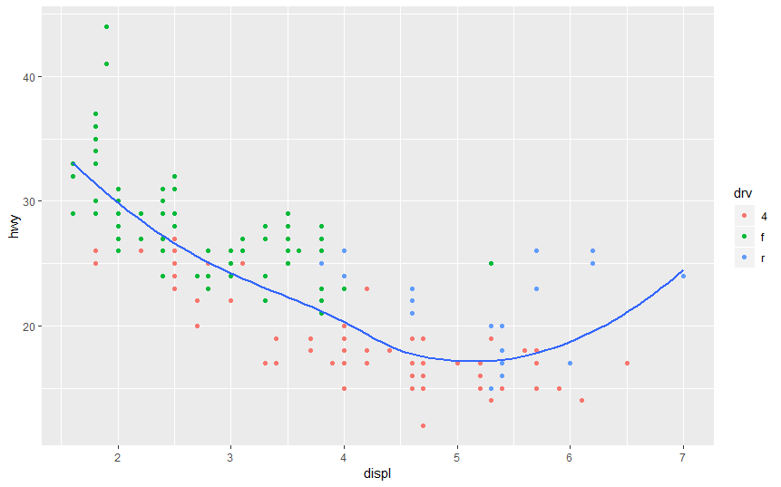

#plot5

ggplot(data = mpg,mapping = aes(x = displ, y = hwy,color=drv)) +

geom_smooth(mapping = aes(x = displ, y = hwy,linetype = drv),se=FALSE)+

geom_point()

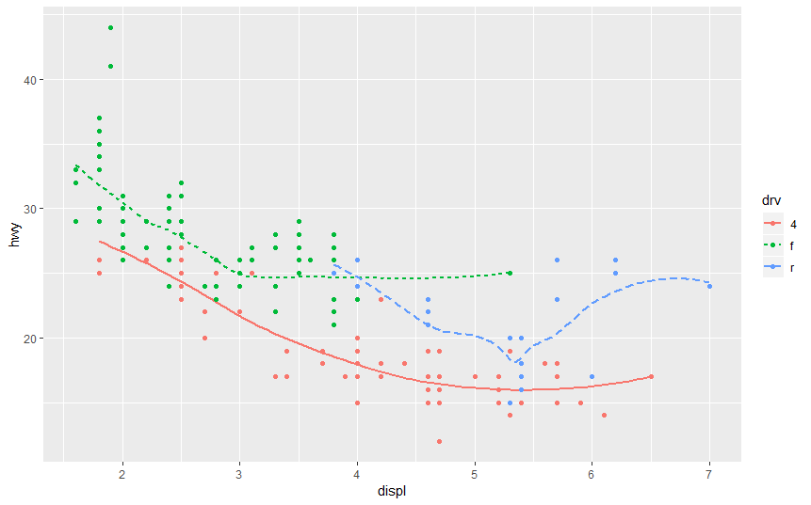

#plot 6

ggplot(data = mpg,mapping = aes(x = displ, y = hwy,color=drv)) +

geom_point()

